Assignment 1 Mobile Robotics:

zain-ul-abideen/ Reg#450682

24/04/2024

2024

Comparative Intelligent Navigation of Pioneer Mobile Robot Using Laser and Camera Sensors

# Abstract:

The work presented in this paper is focused on an autonomous navigation simulation of a Pioneer mobile robot. The objective is to ensure that wherever the set goal is, the robot will always find its way while avoiding any obstacle in its path using at first the data of a laser sensor and at second a camera, and at the end a comparative study between the two kinds of navigation is given.

# Kinematics modelling of robot:

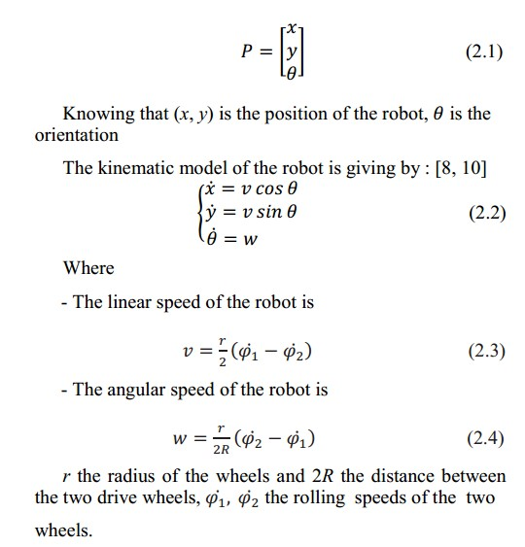

Software: The Robot Operating System (ROS) and Python programming language were used for robot  control and simulation.

Working Principle: Pioneer 3-AT mobile robot equipped with a laser sensor and a camera.

Lidar-based Navigation**:** The LIDAR sensor continuously scans the environment and provides data about the distance to surrounding objects. The robot analyzes the LIDAR data to identify obstacles in its path. Based on the location of the obstacle (left, right, or front), the robot makes a decision to turn left, turn right, or choose another direction to avoid collision.

Goal-oriented Movement**:** The robot calculates the angle and distance to the pre-defined goal position using odometry data. It moves towards the goal while continuously monitoring the LIDAR data for obstacles. If an obstacle is detected, the robot repeats the obstacle avoidance step and then resumes its path towards the goal.

Camera-based Navigation**:**

*Image Acquisition:* The camera captures real-time images of the environment.

*Edge Detection:* The Canny edge detection algorithm is applied to the images to identify the edges of obstacles and distinguish them from the background.

*Obstacle Avoidance:* Similar to LIDAR-based navigation, the robot analyzes the edge information to determine the location of obstacles. It then decides on the appropriate movement (left turn, right turn, etc.) to avoid collision.

Goal-oriented Movement: The robot utilizes odometry data to calculate the necessary movements to reach the goal position. While moving, it continuously processes images from the camera to detect and avoid obstacles.

## Key Points:

*Separate Experiments:* The paper conducts separate experiments for LIDAR-based and camera-based navigation to compare their performance.

*Algorithm Similarities:* The core obstacle avoidance logic and goal-oriented movement strategies are similar for both sensor types.

*Sensor Specifics:* The main difference lies in how each sensor perceives the environment and the specific data processing techniques used (LIDAR data analysis vs. image edge detection).

# Experimentation using Lidar:

## Setup 1:

In this part, we’ll see that the robot can navigate and make it to the pre-defined location in all four quadrants. The axes of a two-dimensional Cartesian system divide the plane into four infinite regions, called « quadrants », each bounded by two half-axes.

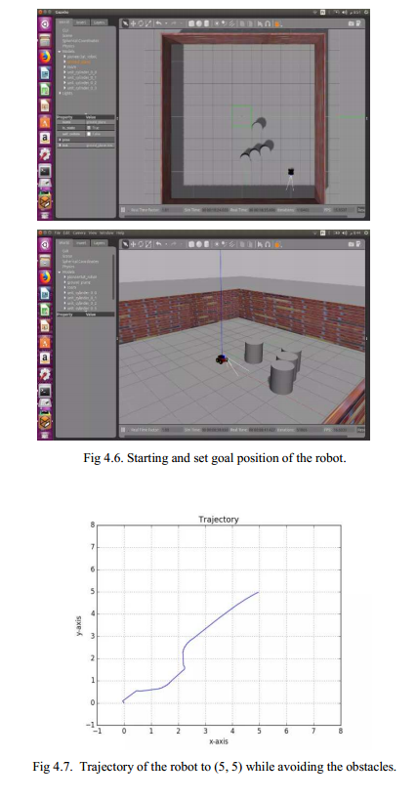



## Setup 2 multiple objects: Quadrant II

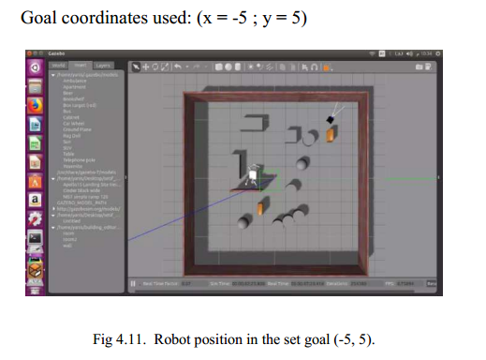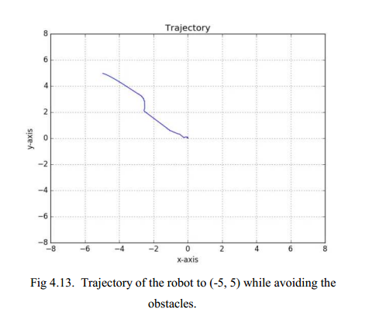

## Setup 3 multiple objects: Quadrant III

## C:\Users\mega computers\OneDrive - National University of Sciences & Technology\Desktop\quadrant 3.PNGC:\Users\mega computers\OneDrive - National University of Sciences & Technology\Desktop\quadrant 3.PNG

## C:\Users\mega computers\AppData\Local\Packages\Microsoft.Windows.Photos_8wekyb3d8bbwe\TempState\ShareServiceTempFolder\in 4th quadrant traffic area.jpegC:\Users\mega computers\AppData\Local\Packages\Microsoft.Windows.Photos_8wekyb3d8bbwe\TempState\ShareServiceTempFolder\in 4th quadrant traffic area.jpegSetup 4 multiple objects: Quadrant IV

# Visualization using OpenCV:

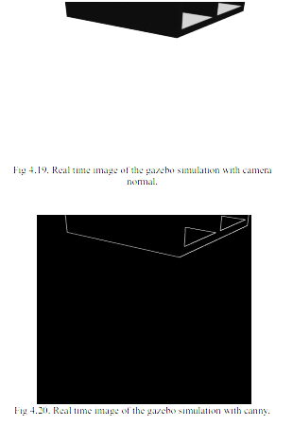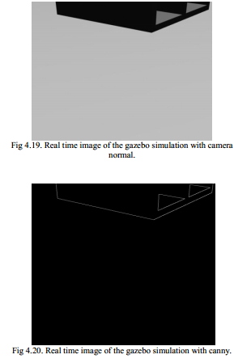In order to get real time image visualization from the camera of the robot we need to use OpenCV libraries to import the necessary features, after we use the canny instruction to detect the edge between obstacles and the ground.

# Experimentation using Camera:

## Multiple objects: Quadrant I Multiple objects: Quadrant II

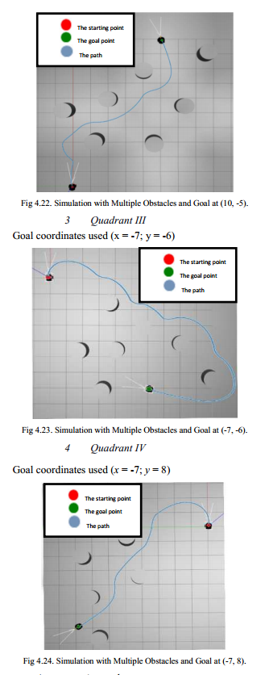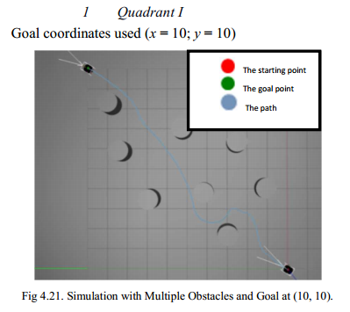

## Multiple objects: Quadrant III Multiple objects: Quadrant IV

## C:\Users\mega computers\OneDrive - National University of Sciences & Technology\Desktop\camq234.PNGC:\Users\mega computers\OneDrive - National University of Sciences & Technology\Desktop\camq234.PNG

# Algorithm:

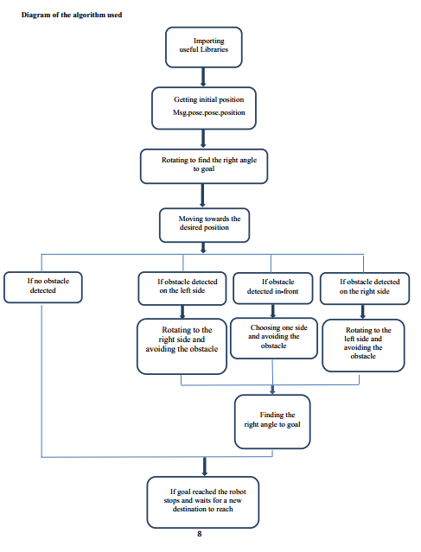

# Conclusion: Comparative Key findings:

### Laser:

* Strength: Fast and efficient obstacle detection over wide area.
* Weakness: inability to detect thin barriers or small obstacles.

### Camera:

* Strength: Ability to detect objects of various sizes.
* Weakness: slower processing time due to image processing.

Both sensors demonstrated successful navigation and obstacle avoidance capabilities. The laser sensor offered faster navigation, while the camera provided more comprehensive obstacle detection.